**Armadale Primary School**

**Cost of the School Day**





All of our staff are aware of the effects of poverty and how it pertains to the context of our school, community and children.

**Getting Dressed for School**

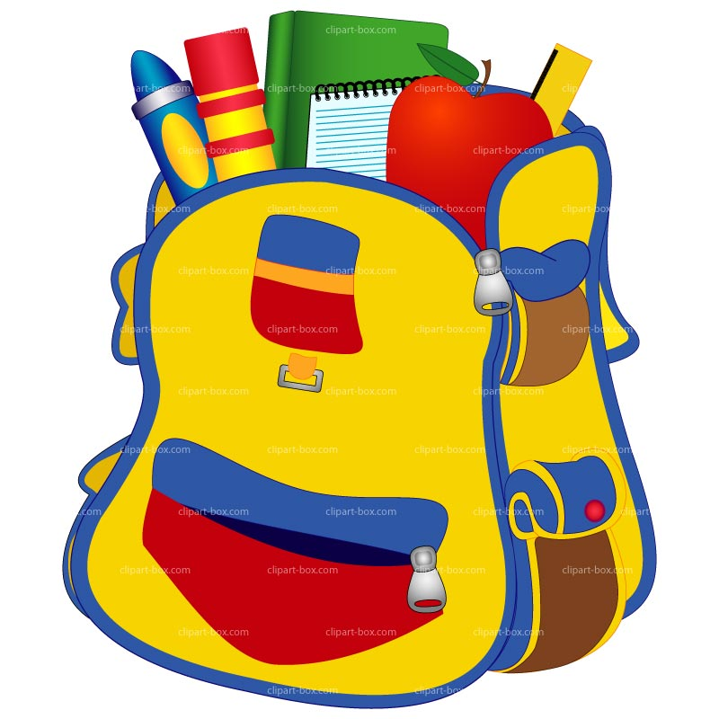

* Universal:

School uniform is a white polo shirt and school jumper and un-embroidered items are acceptable. Any shorts and T shirt are acceptable for PE with the exception of football strips. Primary 7 children on leaving in August 2023 received 2 shirts, a black jumper and a pencil case with pencils, pen, highlighters, a rubber and sharpener.

* Targeted:

We currently have a school uniform bank situated in our family room. This is accessible for all parents and is signposted when needed. This also includes seasonal clothing i.e. coats, hats, scarves and Christmas jumpers. We have access to other school uniform banks and have accessed this service for families.

Family Link worker makes referrals to the West Lothian School Bank Winter Warmer Appeal for winter jackets



**Travelling to School**

* Universal:

Our school serves the catchment of Armadale and almost all children live within walking distance to school. All pupils in P7 can complete Bikability training and bikes and helmets are provided for those in need. After school clubs are run in school where there is no need to travel any distance.

* Targeted:

FSW can support those requiring assistance to complete transport applications.



**Friendships at school**

* Universal:

Uniform is promoted to negate any peer pressure for branded and fashion clothing. While there is a device policy in school all pupils have access to ample digital technology in school. Our Health and Wellbeing curriculum reflects the importance of respect and tolerance. All children in school have received a House Hoodie for outdoor play and PE days.

* Targeted:

We provide Nurture support for social skill development. All classes have a designated member of management to provide continuity in supporting classes, individuals and families when needed. Help is given to anyone who needs a new House Hoodie.



**Learning at school**

* Universal:

Stationery is provided for all classes to access at all times. There are options for resources to be borrowed to support learning i.e. devices, dictionaries, rulers, calculators.

* Targeted:

Reviews are held regularly to provide bespoke learning targets for those children who need support with their learning. This is continually monitored.

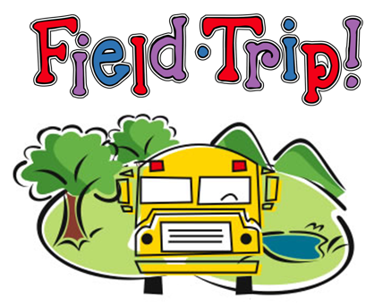

**School trips**

* Universal:

We plan school trips in advance to ensure parents/carers are notified in a timely manner. Class trips are limited to one annually to reduce the cost. We try to source locations that provide free transport to reduce the cost of trips per person. All pupils have the opportunity to attend residential experiences throughout their time at Primary School. These can be paid up through a payment card and we actively encourage pupils to join the credit union. When possible trips are subsidised by the school fund and Participatory Budgeting Model.

* Targeted:

Our family support worker can support families and sign post them for financial help when required



**Fun events**

* Universal and targeted:

Fun events in school including health week, Scottish week and the annual fun day are paid for by the Parent Council and through school fund. We always ask for donations rather than a specific contribution to dress down days and fund raisers.



**Eating at school**

* Universal:

We have a continual link for FSM applications in our on line newsletter. Cashless catering means that there is less stigma attached to pupils eligible for free school meals.

The school operates a free breakfast club for all pupils.

* Targeted:

Snacks can be provided for children who require one.



**Attitudes towards poverty**

* Universal:

Staff have a good awareness and knowledge and understanding of the children and families in our school. Our curriculum is due to be refreshed to allow us the opportunity to explore the issues surrounding poverty and we will continue to deliver our Participatory Budgeting Model to support this.

* Targeted:

Our family support workers offer regular drop-in sessions/coffee mornings and speak with individual families in regard to supporting and sign posting to help available.

Family Link Worker makes referrals to River Kids for Christmas presents for targeted families. Support can be accessed by parents and carers by telephone, face to face or by an on line FORM.



**School clubs**

* Universal:

All in school led/organised after school clubs are run with no charge to ensure these can be accessed by all of our children.

* Targeted:

Our Family Link Worker will sign post and encourage families to attend in school clubs and activities. School staff regularly monitor our learner’s experiences and try to ensure opportunity for all.

**Home learning**

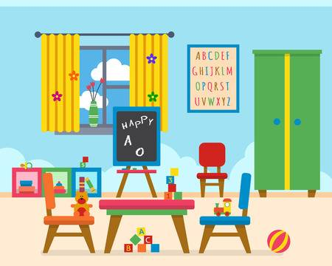

* Universal:

Home learning tends not to rely on ICT. If this is needed time is allocated to complete in school.

* Targeted:

Our Family Link Worker can run homework support sessions to offer help/advice and support when required.

**Family Link Worker**

Our Family Link Worker works alongside our staff, families and children to best support the needs of all of our families and to help reduce the cost of the school day and to narrow the poverty related attainment gap.

